Employee Web Access


Functional Document

Version 1.0

Login
Introduction:
The login screen is used for employee to login for both Full time employees and temporary employees that work at our client locations. The temporary employees can only login after the registration process is completed.
Display Settings:
The screen should load the color combination and logo based on the Division, the division id should be passed in as query string.
If the query string is not available default settings is to load “TemPositions” default logo and color.
Functional Specification:
There are two types of users in our system
- Full time employees that work at TemPositions
- Temporary employees that work at TemPositions client locations
Every login request both success/failure should be logged in audit table.
For the full-time employee, the details are entered by the IT team and the login should be created by signing up screen.
The temporary employee should complete the registration process using our eRegister application. Once the registration process is completed, the user must login to EWA using the same eRegister credentials. On matching details an EWA login will be created for the candidate.
The other way to create login, IT manually creates login for a specific candidate. This is case for old employees that are working at TemPositions client locations before 2011. These candidates do not have eRegister profile.
On successful login, if the password is “test” or if the account is marked as “reset Password” the user should be redirected to “Change Password” screen to update their password.
On successful login, If the query string has the following values the user should be taken to appropriate page. In other case the employee should be redirected to Dashboard.
Query String Page Name
pjb Personal Job Bank
wr Sign Wage Rate
wc W-2 Form
aca ACA Consent Form
ov Pre-K Orientation
aca1095 ACA 1095 – C Consent Form

Dashboard
Introduction:
The dashboard should have quick way to do the following functionality to the users.
- A calendar with upcoming/current Assignments.
- A weekly calendar to display the orders for time entry.
- List of Personal Job Bank job offer
Display Specifications:
The screen should display the calendar to display upcoming/current assignments. A weekly calendar for timesheet entry and a grid with list of personal job bank job offer that can be accepted/declined or waitlisted.
Functional Specifications:
The following are the 3 features that needs to be shown. As this is the dashboard, the user can only view the information. For performing any action the user should click the appropriate option to navigate to the action page.
- A calendar with upcoming/current Assignments in the duration of current month should be displayed. On clicking the event/assignment the details of the assignment will be displayed. Please refer the Assignments page for the details.
- A weekly calendar to display the orders the candidate is currently assigned to and on clicking of the order the user will be taken to time entry screen. All the checks need to be performed in this case.
- List of Personal Job Bank, job offer that are sent to candidate should be displayed on the dashboard. This should only be a view so that the users can click the day and that will take to the personal job bank.

Menu Links
Introduction:
The left navigation links and access to the page are division specific and user specific. This section explains on the visibility of links.
Design Specification:
Each link has been divided based on type of action. If no sub menu items are available, the menu item should be hidden. The submenu should be highlighted based on the page the user is on. Eg. If user is on time entry screen in left navigation, the appropriate menu should be expanded and submenu item should be highlighted.
Functional Specifications:
The links are available to the user based on division the candidate is on and sometimes the link is displayed based on the order the user is currently working on. The following should explain in detail all available links and condition for displaying the link.
- Division Log: The logo and skin is loaded depending on the division the candidate is in. On clicking the logo, the user will be taken to the dashboard.
- Dashboard: This will be displayed to all the users regardless of the division. On clicking the link the user will be taken to the dashboard page.
- View Messages: This page is visible to all the candidates regard less of divisions. But the link is hidden for the Full-time Employees.
- Enter Availability: The page is available to all the candidates regardless of divisions. But the link is hidden for the Full-time employees.
- View Time Slips/View Your Attendance: This link is available to all the candidates except the full-time employees. For Division 87 the label will display as View Your Attendance and all other divisions the text is “View Time Slips”.
- Personal Job Bank: this link is available to all the candidates except division 87 and full-time employees.
- View Pay Stubs: This link is visible to all the division, except if the candidate is an independent contractor.
- View Employee Benefits: This link is hidden to candidates working at On Call Counsel, NY Law Dept. and full time employees.
- Enter Attendance/Enter Time Slips: This link is visible to all the candidates and is hidden for full time employees. If the division of candidate is 87 the text will be “Enter Attendance” and for rest of the divisions, the text is “Enter Time Slips”.
- Enter Student Grades: This label is only visible for candidate in division 87.
- Modify Skillset: This link is only visible for candidate in division 33.
- Assignments: This link is hidden to only full time employees and candidate in division 87
- Request Paid Sick Leave: This link is only visible to all the divisions except full time employees. The condition is the candidate has worked at least 120 calendar days after the candidate first work for us after April 1st 2014. Or if the candidate is rehiring and candidate has worked previously and have taken a PSL the link will be displayed.
- Upload Resume: This link is visible to all the divisions except 87 and Full-time employees.
- Change Password: This link is visible to all the users, including full-time employees.
- Sign Wage Rate Form: The link will not be displayed if the candidate is an independent contractor. The following are conditions to display the wage rate:
  - If the candidate has not signed the wage rate only this display the link.
  - If the wage rate has been updated in IntelliStaff - Interview Tab, the link will be displayed.
  - Every year an annual email goes out to temp to resign wage rate form, in this scenario too the link will be displayed.
- Edit Payment Method: This will be displayed to all the candidates except the Full-time employees.
- Columbia Temporary Associate Agreement: The link will be displayed to the candidates who work at client “Columbia University (Master ID# 27326) and has not signed the agreement.
- Employee Handbook: This link is displayed to candidates in all the divisions except division 101, 102 and full-time employees.
- W-2 Form: This link is displayed to all the users both Temporary and Full-time.
- ACA Consent Form 1095-C: This link is visible to all the users both Temporary and full-time.
- ACA Form 1095: This link is visible to all the users both temporary and full-time.
- Current Pay Rate Schedule: This link is visible to only School Pros’ division and School Pros UPK. That is division 50 and 117.
- Corporate Perks: This link is visible to all the users (both Temp and full-time) except Independent Contractors.
- Update Employee Profile: The link is visible to all the divisions candidates who have completed the eRegister profile. This links is hidden for full-time employees.
- ACA Form Electronic Delivery Consent: This is visible to all the users both Temp and Full-time.
- SCR Consent Form: This is only visible for Division 50 and 117.
- Disclosure Consent Form: This is displayed for divisions 50 and 117.
- Terms and Conditions: This is displayed to all the division except independent contractor and full-time employees.
- Consumer Reports: This link is only displayed to all the temporary employees.
- Pre-K Educator Orientation: The link is only visible for division 117.
- 211 Waiver Memorandum: The link is only visible for candidates in division 101.
- Upload Credentials: This link is only visible for candidate in division 50 and 117
- Upload Candidate Photo: This link is only visible for the candidate in division 50 and 65
- Medical Coverage Enrollment: This link is visible to candidates who are eligible for insurance. The eligibility email will be sent once the candidate starts working with us.
- Transit Check: This is visible to all the users except independent contractors.
- Employee Handbook/Terms & conditions: This link is visible for the candidate in division 101.

View Messages:
Introduction:
The message is a way to broadcast a message to all the Temps in a specific division. In IntelliStaff a message can be added to a division and all the messages will be displayed in EWA.
Design Specification:
All the messages should be displayed in grid format as they currently display in existing site.
Functional Specification:
A user from this screen can do the following actions:
- View Message
- Delete Message
- Respond to message
If a user comes to this page, then we consider all the messages to be viewed.
If a user deletes the message, the message will not be displayed in the grid any more.
If a user responds to a message, an email goes out to the personal rep of the candidate. If no personal rep is available, the email goes out to notification email in divisions table.

Enter Availability:
Introduction:
This screen is used by the temporary employees to enter their availability for the current and future weeks. Some of our automated applications send job offers to the candidates based on this availability.
Design Specification:
We do not have to many design changes on this screen, the screen would look like screen in legacy application. Only change is instead of dropdowns we need to add time control for time selection, instead of dropdowns.
Functional Specification:
On this screen the user should be able to clear the schedule or enter his availability for the week. Only for division 113 display 7 future weeks. For all the other divisions allow users to pick only 3 weeks to enter the availability.
If the candidate is already on order, disable ability to update the availability. **
If the candidate is trying to enter availability in middle of week, disable the previous days. **
** This is not high priority but if this is not implemented we can implement after our release.

Personal Job Bank
Introduction:
When a job offer is made to a candidate via IVR or email or SMS an option to accept/reject/waitlist will be displayed in this section.
Design Specification:
The design will be the same as legacy application, a grid to display list of job offers. For reject button, a modal popup should be displayed to capture the reason for the rejections.
Functional Specification:
When a job offer is sent to the candidate from requirements Find Temps screen in IntelliStaff, the offer should be displayed in the screen. The offer can be an Email Job Offer or IVR Job Offer or SMS Job Offer, in all these cases the candidate should be able to Accept or Reject or Waitlist to the Job offer.
On accept click, the following checks needs to be performed:
- Check if the order is filled, to know if the order is filled we need to check the no of temps required for this order and check if the order has temps assigned. E.g. Order requirement is 2 temps, check if 2 temps have already accepted the job.
- Check if the candidate is already assigned to an order that conflicts with current orders schedule.
- There are more checks that are performed, like candidate I9 completion, client paying bills etc.
- On Job Offer screen on IntelliStaff, if assign automatically is not checked the candidate will not be able to assign to the order. A message to contact personal rep will be displayed.
On success of all the checks the following are the actions:
- Candidate gets assigned to order and will display under candidate section of order tab.
- Candidate will be displayed in requirements section of order.
- Candidate availability button will be shown as booked (blue color)
- If the no of temps’ match against no of candidates on order, “filled by” and filled by date will be updated.
- The auto send email process will pick up the confirmation emails and send out to both client and candidate (this is a separate asynchronous application that runs on one of our servers)
- A note gets added to both candidate and order that confirmation emails have been sent.
- A send/remind will be sent to personal rep of the candidates.
For reject, a modal popup will be displayed to collect the reason and comments for the rejection.
For waitlist, a candidate will be able to waitlist to the job offer and if some candidate backs out the recruiter will be able to assign a waitlisted candidate from IntelliStaff.
Here are some of the checks:
- Candidate rejected should not be able to accept the job offer until someone changes the entry to “Interested” in IntelliStaff.
- Candidate once accepted cannot reject the job offer, the candidate must call the office to change his option

Enter Time Slips:
Introduction:
This screen is used by all divisions except On Call Counsel, NY Law Dept. client for entering their timesheets.
Design Specification:
We need to use the same look as legacy application. There are couple of changes in the flow of the application:
- For Time Sheet confirmation, just show a popup. In current system, we navigate to different page.
- Change the time entry dropdowns to time control.
Functional Specification:
For entering time, we need to select the weekend first. The screen should display weekends for the past 3 months to select from.
On selecting weekending, the following checks needs to be performed:
- Check if the candidate has signed ACA form
- Check if the candidate has signed handbook
- Check if terms and conditions are signed
- Check if consumer reports are signed
- Check if gender equality notice has been signed
- Check if Conscientious Employee Protection Act notice has been signed
- Check if ACA 1095 C has been signed
- For Divisions 50, 117, 55, 112, check if disclosure consent form has been signed
- Check if CA Wage rate from has been signed.
- Check if candidate pay card change has been acknowledge. (The card change from chase to Bank of America)
- Check if the candidate needs to complete the ACA survey.
- Again, check and make sure the candidate is not currently working on NY Law Dept. order, if he is redirect to law dept. time entry screen.
- Wage rate also needs to be signed again every year and if the wage rate has been changed for candidate on interview tab of IntelliStaff. Currently this functionality is implemented on the Timesheet entry screen. We must move this so that the candidates will not be able to enter timesheets unless the form has been signed.
On success of all the checks, we need to fetch orders and their schedules and displayed as radio buttons.
One additional condition here is, if the candidate is working on a DOE order, we need to display a small message on the top of the orders grid.
SINCE FISCAL YEAR 2015 STARTS TUESDAY, JULY 1, 2014, PLEASE ENSURE THAT YOU ENTER YOUR …

On selecting the order, the candidate should be taken to time entry screen. The time entry differs based on the order the candidate is working on.
Division Time Interval
SP Payroll 1 Min
On Call Counsel 6 Min
All Divisions 15 Min
On this order selection screen, if the candidate is logged in as division 87, the user will be taken directly to this screen but not the weekend select screen. ** We just should write the code, this is currently an inactive division so cannot test now**
The following are the checks on ‘Enter Timeslip’ page for all other divisions;
- Current page has checks for Wage rate, but this has been removed and added to checks when the user selects “Enter TimeSlips” link. So Please make sure the code is removed. A small correction, we need to check this once the order is selected. So, the check will be performed once the order is selected.
- Current page has checks for HealthCare Code of Conduct, but this has been removed and added to checks when the user selects “Enter TimeSlips” link. So Please make sure the code is removed. A small correction, we need to check this once the order is selected. So, the check will be performed once the order is selected.
- If the total hours are more than 12 hours warn the user and get a confirmation to make sure there is no user mistake.
“Your time entry for certain days exceed 12 hours per day. Are you sure this is correct?”
- Check for holidays during the week and if the user entered time for holiday, warn the user and get a confirmation.
You have entered time for [hol_day], [hol_date] which is a holiday. Did you work this day?
- Only show the days with having schedule. In other case disable the days’ entries in timeslip for the following conditions:
  - If the divisions have “hide_unscheduled_ts_days” flag checked for divisions table in database.
  - For all the orders in DOE, only show scheduled days.
- Lunch break must be in increment of below time intervals based on divisions:
Division Time Interval
SP Payroll 1 Min
On Call Counsel 6 Min
All Divisions 15 Min
  - For division 59, minimum of 30 minutes of lunch break must be entered over daily hours of 7.5 (Per Connecticut law)
  - For divisions 29, 81, 92, 34, 33, 113, 115 (California divisions), minimum of 30 minutes of lunch break must be entered over daily hours of 5 (per California state law)
  - For all other New York divisions, minimum of 30 minutes of lunch break must be entered if the daily hours are more than 6.
Divisions Hours More than Min Lunchtime
59 7.5 30
29, 81, 92, 34,
33, 113, 115 5 30
All NYC divisions 6 30
If the lunch break is not entered, just alert the user with the following message:
Connecticut (Division SELECT * FROM divisions WHERE PayStub_Div_State = 'CT'):
“We noticed you did not record a lunch break. Under Connecticut state law, you must take a meal break of at least 30 minutes when you work over 7.5 hours. Going forward, please be sure to do this, or contact your personnel representative with any questions.”
California (Divisions – SELECT * FROM divisions WHERE PayStub_Div_State = 'CA'):
“We noticed you did not record a lunch break. Under California state law, you must take a meal break of at least 30 minutes when you work over 5 hours. Going forward, please be sure to do this, or contact your personnel representative with any questions.”
NY Divisions (SELECT * FROM divisions WHERE PayStub_Div_State = 'NY'):
“We noticed you did not record a lunch break. Under New York state law, you must take a meal break of at least 30 minutes when you work over 6 hours. Going forward, please be sure to do this, or contact your personnel representative with any questions.”
- Here are some more additional checks divisions 101 & 102 (DOE)
  - Temps cannot enter time if there is a pending waiver for approval.
  - Temp cannot enter time if I9 verification is pending. (SP: spGet_Avail_Jobs_ByDate_5).
  - The candidate must clear PETS Screening, that is candidate should have Skill id, 1857 (PETS Cleared) in cand_pos_skills.
  - Temp should not be allowed to enter the time sheet before the I9 completion data. (check using function dbo.GetDOEI9ComplDate, where the week ending date must be greater than I9 completion date)
  - Temp should not be able to enter the time sheet unless the order has a PO number (or) during starting of fiscal year that is “July 1st” from certain period we allow candidate to entire time if the order has “Pending PO” the candidate will be able to enter time.
  - The time cannot be entered that will result in daily payrate over $500 without an approved waiver. (Time sheet approver needs to request for a waiver and entry gets created in order_doe_waivers table).
  - Total daily hours cannot exceed 7 hours (To create an exception, need to create an entry in cand_doesp_day_hr_limit_exceptions table).
  - Even after exception, total daily hours cannot exceed 10 hours.
  - Temp can only work set number of hours that was entered while creating the order. So, if a user enters hours more than order hours the following message needs to be displayed. (SP: tpweb_ewa_get_hours_left_on_order)
You have entered in [ timesliptotal] hours for the week. As you heard from us by email, per our records, the Purchase Order connected to your assignment has been exhausted and there are only enough funds to pay for [order_hrs_left] hours of work.
You may only enter in those hours now. If your supervisor, [supervisor] increases the PO amount, you can revisit the site and enter the additional hours.
To do that simply log in again, enter a timeslip for the same weekending, and fill in the hold over hours. Additionally, you should NOT work any more hours until you receive an
email from us tell you additional monies have been added to the PO and you are authorized to resume work.
If you have any questions, please contact us at info@schoolprofessionals.com or call us at (212) 916-0805
  - Temp should not be able to enter timesheet if the projected amount for the order for the hours left before going over $50,000 for fiscal year or calendar year. (SP: tpweb_ewa_get_total_ytd_pay_for_candidate). To add an exception for more than $50,000 in a fiscal year or calendar year, need to insert an entry in cand_doesp_waivers with waiver_type = 1)
- For candidates working on School Nurse divisions (7 and 16), we need to collect hours based on activity they performed on the day.
  - Total daily hours must match with their corresponding activity hours in bottom part of a timesheet.
  - We need to display a small message on the top of timeslip page
“As of 10/13/2014 the Department of Education will be billing Medicaid for nursing services that are provided during the school year. Please fill in the grid below the time sheet allocating how many hours each day you spent delivering each service.”
- Display a row “Taxi” for the order if Taxi is enabled in IntelliStaff. In requirements screen of IntelliStaff, if charge for taxi is enabled then candidate will be able to enter taxi. Also candidate should be able to enter taxi only on the days they are working.
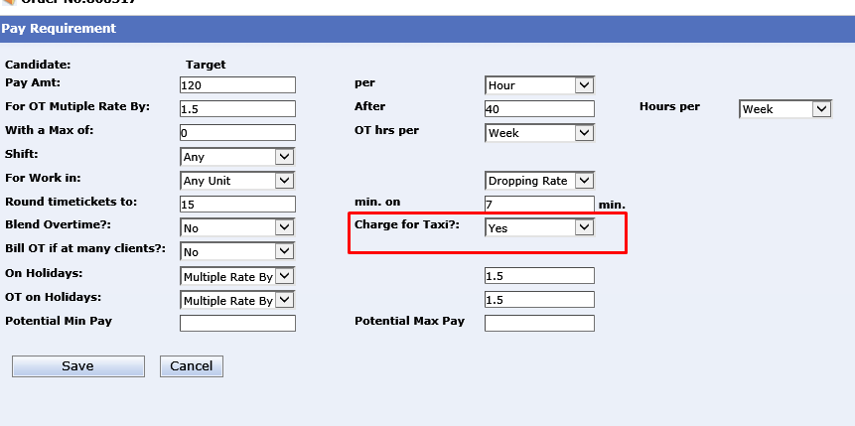
- For the candidates working in AOC division (division Id 115) and order have “Charge for Taxi” as “1”, the candidate needs to upload a receipt of the taxi fare. This uploaded document will be sent as part of invoice to the client, so this must be verified. The following are the 2 checks:
  - Expense amount should only be entered for days the candidate has worked.
  - There should be at least one receipt uploaded.
- The candidates working on the order of division School Nursing (97,16, or 7), disable lunch fields. (SP: spGet_Check_If_Client_BOE_Nursing)
- The timesheet cannot be entered with “0” Zero hours. A minimum of 0.5 hours is required for a timesheet.
- Start and end time cannot be the same.
- The total hours cannot go negative, example is start time 8:00 AM – End At 10 AM, with lunch as 3 hours, this is a user error but have seen this kind of data.
On submitting timesheets, the following are the checks:
- Check and make sure the timesheet does not conflict with a pending time sheet or an approved timesheet or a paid sick leave request that is entered. (sp: sp_time_find_duplicate2)
- We have the following algorithm to get the timesheet approver.
  - There might be multiple order approvers, but the first one is the primary approver.
  - If no order approver is specified and on client’s screen, contacts section we have a button “Time Approval Process” in there the checkbox is checked to use report to is timesheet approver check (this in creates an entry in “order_approval_i” when order is created)
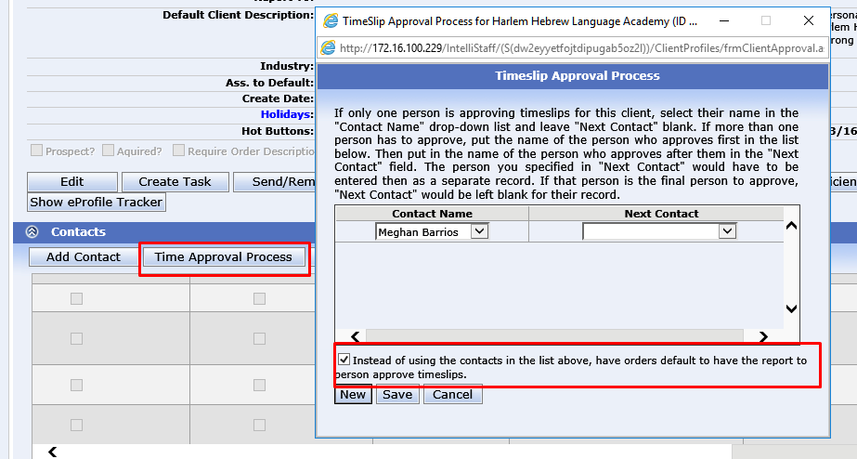
  - If no order approver is specified i.e. the above 2 conditions does not return any data, we need to get client approver and the first client approver is the timesheet approver.
- If there is an issue with DOE Purchase order that is there are “no funds”, email PO Certifier that there are no funds on the order.
- After timesheet is saved an email needs to send to the timesheet approver. This information is pulled from client billing in IntelliStaff. (The email is not sent from this screen for DOE, there is a separate automated application that sends the email)
  - If TimeSlip Email Type = 0 send 1 email per timeslip entry.
  - If timeslip Email Type = 1, sent 1 email per weekend.
  - If timeslip Email Type = 2, no email should be sent to the client.
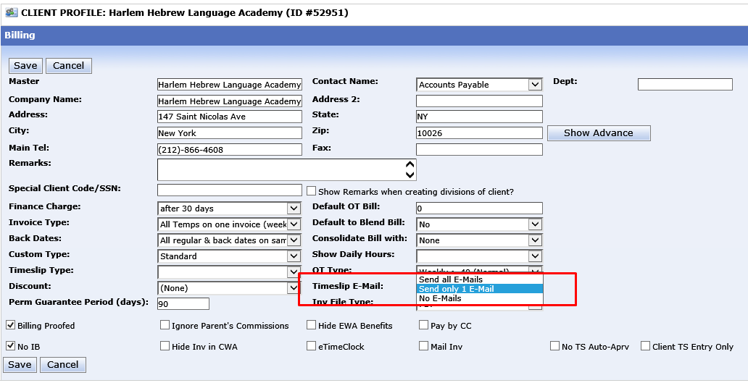
- On successful submission, a confirmation number needs to be generated and needs to be displayed to the user.

NOTE: There is code for creating entries in student tables, this is for division School Professionals SES and we must comment out the code as this is not used any more.

Pay Stubs:
Introduction:
This screen is used by both temp and permanent employees to view their paystub.
Design Specification:
The display should be the same as current application. There should be a button to print the paystub and view list of paystubs.
Function Specifications:
This screen pulls the information from Great Plains our pay rolling system. If the candidate has 2 pay stubs for a week, the 2 paystubs will be displayed one below the other on the same scree. The screen displays the following information:
- Company/Division Information
- Employee Information and Check information
- Pay Data
- Deductions
- Adjustments
- Summary
- Client Name (Only for CA)
- Paid Sick Leave (Only for CA)

- Company/ Division Information:
This section displays company information that the candidate is working for. Currently we have the following companies.
  - TemPositions Health Care, Inc.
  - TemPositions, Inc.
  - Essey, LLC
  - SP Payroll Processing
  - Essey Group, LLC
  - Essey Holdings, LLC
Candidate division is mapped to one of the above companies. Here is the query to get mapping:
select * from vwdep_class
In name of employer, {GP Company name}, dba (Doing Business As) {Division Name} will be displayed.
The address and phone number will be pulled from “Divisions” table.
- Employee and Check Information:
This section displays the information about employee and check information. Here are the details:
- Employee Name
- SSN (Masked and displays last 4 digits)
- Pay Period of the check
- Check Date
- Check Number
All the above information is directly pulled from Great Plains.
- Pay Data:
In this section, all the pay information will be displayed. Are these regular hours, any overtime hours etc. The following are type of information displayed in this section.
- Regular Hours: these are the regular hours the candidate has worked. So if a candidate worked 4 multiple assignments, 4 lines of pay will be displayed.
select* from total_sum_pay where PayCode = 'TEMP' and BillDate = dbo.GetWeekEndingDate(-1, getdate())
- Over Time Hours: if a candidate works more than 40 hours in a week, then we consider the hours more than 40 as over time and the information is displayed in this section.
Here is the query to get that candidate, pick up any candidate from the list:
select* from total_sum_pay where PayCode = 'OVER' and BillDate = dbo.GetWeekEndingDate(-1, getdate())
- 10 HOUR SPREAD BONUS (This is for Hospitality if the candidate works more than 10 hours per day they get paid 1 hour of bonus)
Here is the query to get that candidate, pick up any candidate from the list:
select* from total_sum_pay where PayCode = 'HSPD' and BillDate = dbo.GetWeekEndingDate(-1, getdate())
- Bonus: If a candidate refers someone and works or any sort of Bonus will also get displayed in this section.
Here is the query to get that candidate, pick up any candidate from the list, if no candidates found select different weekend -2, -3 etc.
select* from total_sum_pay where PayCode = 'BON' and BillDate = dbo.GetWeekEndingDate(-1, getdate())
- JURY DUTY: If a candidate is on Jury duty the candidate gets paid for the days he is on duty.
Here is the query to get that candidate, pick up any candidate from the list:
select Top 10 * from total_sum_pay where PayCode = 'JURY' order by BillDate desc
- PAY ADJUSTMENT: An adjustment made to add the pay amount
Here is the query to get that candidate, pick up any candidate from the list:
select Top 10 * from total_sum_pay where PayCode = ‘ADJ’ order by BillDate desc
For School Profesionals:
select Top 10 * from total_sum_pay where PayCode = 'SPADJ' and BillDate = dbo.GetWeekEndingDate(-1, getdate())
- EXTENDED DAY: This is only for school professionals. The pay for school professionals is calculated on hours they worked
- Hours <4 – Half day
- Hours > 4 and <= 8 – full day
- Hours > 8 – Extended day
- PAID SICK LEAVE: If the candidate has requested a paid sick leave and got paid this week, a line item will be displayed in this section.
select Top 10 * from total_sum_pay where PayCode = 'SICK' and BillDate = dbo.GetWeekEndingDate(-1, getdate())
- TRIP: This is for the BOE School Nursing candidates, that is candidates working in division 7 and 16. Here is the query:
select Top 10 * from total_sum_pay where PayCode = 'TRIP' and BillDate = dbo.GetWeekEndingDate(-1, getdate())
- UNIFORM CLEANING: This is for the candidate in hospitality division (55, 65). The candidate gets paid for cleaning the uniform. Here is the query.
select Top 10 * from total_sum_pay where PayCode = 'UNCL' order by BillDate desc
- VACATION HOURS – TEMP: If a candidate works 1200 hours in a 1 work year, that is from the employment date to employment date + year they will get paid for 1 week of bonus pay. This is also displayed in this section.
select Top 10 * from total_sum_pay where PayCode = 'VACN' and BillDate = dbo.GetWeekEndingDate(-1, getdate())

- Deduction:
In this section, all the regular deductions related to taxes are displayed.

The following are the fields that are displayed:
- Gross Pay
- FICA
- Medicare
- FIT
- State
- City
- Disability
- 401 K
- Adjustments:
In this section, all miscellaneous deductions/payments will be displayed. The following are the types of information displayed:

- Taxi: If a candidate gets paid for taxi this information will be displayed in this section.
  - select Top 10 * from total_sum_pay where PayCode = 'Taxi' and BillDate = dbo.GetWeekEndingDate(-1, getdate())
- Advance: The user in W-2 can select advance deductions made from check. These advance deductions will be displayed in this section.
  - For NY Candidates:
  - select * from Total_Sum_Ded where PayCode = 'ADVNYT' and BillDate = dbo.GetWeekEndingDate(-1, getdate())

  - For SF Candidates

  - select * from Total_Sum_Ded where PayCode = ‘ADVSFT’and BillDate = dbo.GetWeekEndingDate(-1, getdate())

- CHILD SUPPORT: This is an additional deduction we make for the candidate are displayed in this section.
  - select * from Total_Sum_Ded where PayCode = 'CHILD' and BillDate = dbo.GetWeekEndingDate(-1, getdate())
- MEDICAL INSURANCE: the deductions that are made for Insurance are also displayed in this section.
  - select * from Total_Sum_Ded where PayCode = 'HMONY2' and BillDate = dbo.GetWeekEndingDate(-1, getdate())

- MEC: This is minimum essential coverage and this is basic insurance that we provide. This deduction type is also displayed in this section.

  - select * from Total_Sum_Ded where PayCode = 'MEC' and BillDate = dbo.GetWeekEndingDate(-1, getdate())
- TRANSIT CHECKS: Candidate who enroll in transit Check will have deduction every 3 week of the month. This will be displayed in this section.
  - select * from Total_Sum_Ded where PayCode = 'TRANS' and BillDate = dbo.GetWeekEndingDate(-1, getdate())
There might be other type of deductions that get displayed in this section. These deductions are manually entered while paying the candidate.
- Summary:
In this section, we display the summary with no of hours worked by paystub, adjustments and net pay.

- Client Information:
By law for CA employees we need to display the client they worked, along with the rate information.
Here is the query:
select Top 10 * from total_sum_pay T1 INNER JOIN vwCan_Prof_Gen T2 ON T1.Cand_ID = T2.Cand_ID
where PayCode = 'TEMP' and BillDate = dbo.GetWeekEndingDate(-1, getdate())
and T2.State = 'CA'
- Paid Sick Leave Hours:
This section is only for candidates working on California. The law is we need to display the hours they accrued for Paid Sick leave by State, City and County.
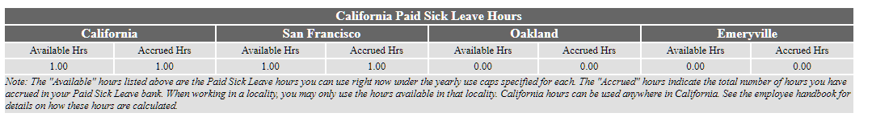
select Top 10 * from total_sum_pay T1 INNER JOIN vwCan_Prof_Gen T2 ON T1.Cand_ID = T2.Cand_ID
where PayCode = 'TEMP' and BillDate = dbo.GetWeekEndingDate(-1, getdate())
and T2.State = 'CA'

